Your Child’s Vision – Advice for Parents

Short-sightedness (myopia) is more common now than when you were a child. This is in part due to living in urban areas and children spending a greater amount of time on close tasks. It’s predicted that half the world’s population will be short-sighted by 2050.
If you’re short-sighted, your child’s risk of becoming short-sighted is twice that of the average child. If your child has two short-sighted parents their risk is six times greater.
Apart from having to wear glasses or contact lenses to see clearly, or perhaps having laser surgery when you’re older, being short-sighted increases the risk of sight loss in later life from conditions such as cataracts, retinal detachments, glaucoma and myopic maculopathy. The risks increase with the degree of short-sightedness.
Ways you can help reduce the likelihood your child becomes short-sighted
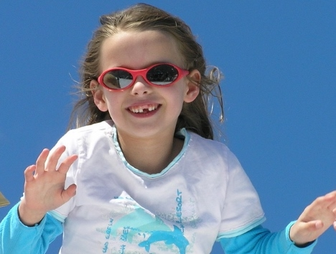
- Outdoor time. All Children should spend at least two hours a day outside during daylight hours. If you’re choosing a day care or kindergarten, try to find one with good outdoor space. Walking to school is great and so is playing outdoor sport. Encourage your child to go outside during breaks at school. As a family, consider having some meals outside, play some outdoor games, go for walks together. or go to watch outdoor sport.

- Limit time on close tasks and put down those devices. Digital device use for children under two should be very limited. For the two to fives an hour the aim is under an hour a day, and for school age children time on close tasks outside school hours should be limited to two hours or less. We realise that this is hard, but we’re encouraging you to try your best. Anyone doing a close task should take a twenty second break every twenty minutes (the 20/20 rule) and look at something in the distance for twenty seconds.
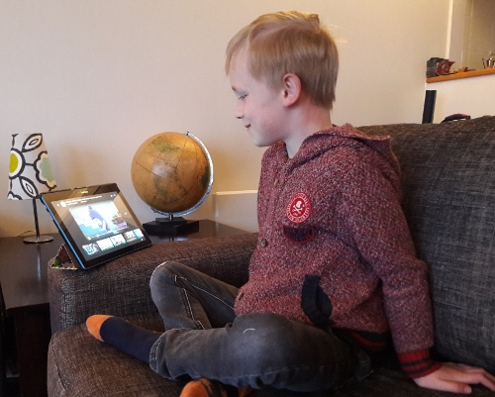
- Make sure close isn’t too close. The object your child is looking at (book, tablet, phone, model or craft project) shouldn’t be any closer to the eye than the “Harmon Distance”. This is the distance between the knuckles and the elbow and is considered the optimal distance for close tasks. Try it out by having your child place a closed fist against their eye or under their chin and then holding a book or device at the tip of the elbow. The book shouldn’t come any closer than their elbow.

- Schedule Eye Exams. Children have a basic sight test as part of the Plunket B4 school check which can identify obvious immediate problems, but every child should also have an eye exam with an optometrist around the time they turn five. You’ll find out how well they see and whether they’re up to the visual demands of being at school. We’ll assess colour vision, eye muscle co-ordination and general eye health. Importantly, how long or short-sighted your child is at age five is a great predictor of how likely they are to become short-sighted and how closely they should be monitored. We can tailor a follow up eye exam schedule to your child’s individual needs and risk factors.

- Don’t despair. If your child does become short-sighted, we can recommend the best options to help limit how short-sighted they become and minimize the risk of eye problems later in life. Efforts you put in up to this point may have delayed the onset of myopia, so it wasn’t wasted.There are now specialised "myopia control" contact lenses, spectacle lenses and prescription eyedrops. The optometrists and dispensing opticians at Sercombe and Matheson are up-to-date with best practice in myopia management. More information is in our sheet “Helping your short-sighted child”.

